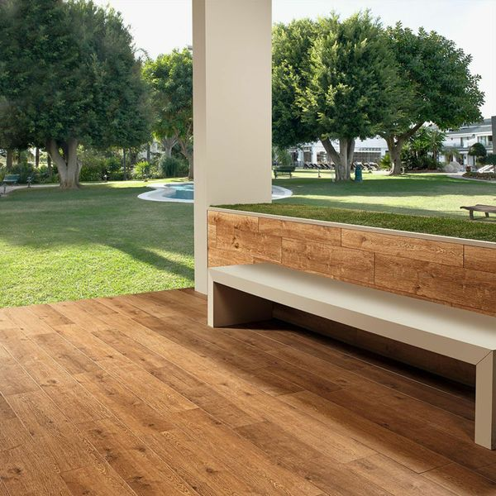**Madagascan Ipil:**

## **Product Description**

Invite the sought-after natural look into your home this season in the form of these Dark Honey Tiles. They have a lifelike wood effect design, and are alive with wood grain and knots; perfect for piecing together a realistic wooden floor space in your lounge, hallway, kitchen or bathroom. To get the full effect, why not order a full-size sample tile? Samples come with free delivery. For an attractive floor display, try creating a herringbone parquet style pattern.

## **Product Info**

* Product ID: 14684
* Tiles Per SQM: 3.6231884057971
* Sale by: Per SQM
* Size: 230x1200x10mm
* Weight: 6.22 KG
* Material Type: Porcelain
* Finish: Matt
* Colour: Brown
* Suitability: Floors, Walls
* Grade: 5
* Rectified Edge: No
* Underfloor Heating: Yes
* Document: [View Layout Designs](https://m2.wallsandfloors.co.uk/media/amasty/amfile/attach/dark-honey-wood-effect-tiles-madagascan-ipil-tree-tiles-.pdf)
* Thickness (mm): 10